New Crust Pizza “Simply Better” Range: Review

Hi everyone,

I recently was invited along to an exclusive event in Bondi held for Nuffnang bloggers by the team at Crust Pizza to launch their exciting new “Simply Better” range and introduce us to the company’s pizza innovations.

My involvement has been sponsored, but as always, all the opinions and information shared here are my own. I only select and agree to attend and take part in sponsored activities that I feel will be relevant and useful to you and the rest of the TD community.

The Crust Pizza new “Simply Better” range aims at profiling nutritious fresh ingredients such as spelt and wholemeal bases, locally sourced fresh produce, as well as top quality house cooked meats.
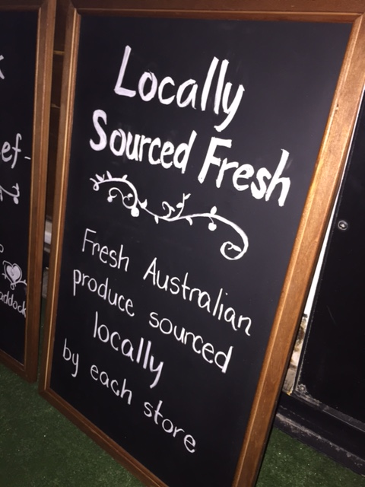

There were three new pizzas introduced to us:

Biltong Spiced Lamb
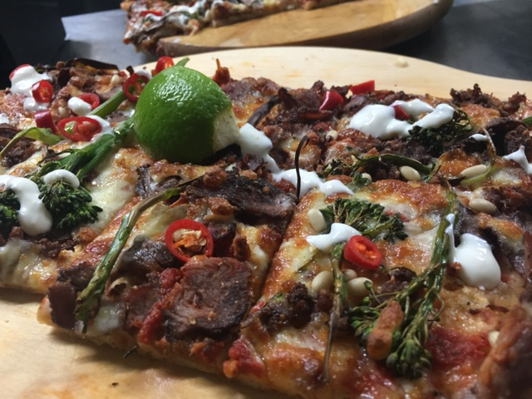

The broccolini and lamb tasted really fresh, and I could just feel that they were adding in a whole lot of nutrients to a pizza meal that could otherwise not be the most nourishing option.

For anyone that enjoys zesty citrus flavours, the addition of the lemon yoghurt and lime wedge (that you squeeze on top) gave this pizza a really refreshing pop to round off the flavour profile on this dish perfectly!

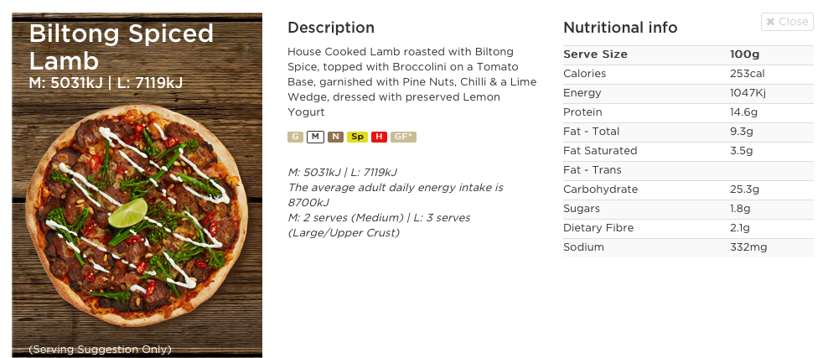

Harissa Hummus Chicken

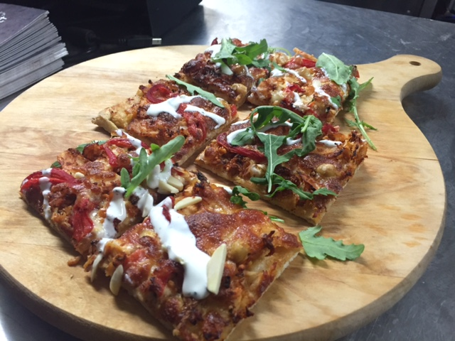

This one appeared to be a surprise favourite by quite a few of us at the event!

The use of hummus in place of a tomato based sauce was absolutely delicious, and the marinated chicken was bursting with flavour and definitely reminded me of the middle eastern flavours I had just recently enjoyed on my trip to Israel a few weeks ago!
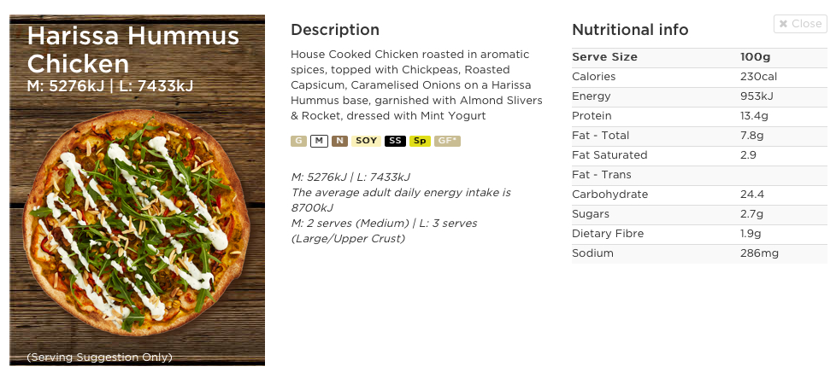

Wagyu Shoga

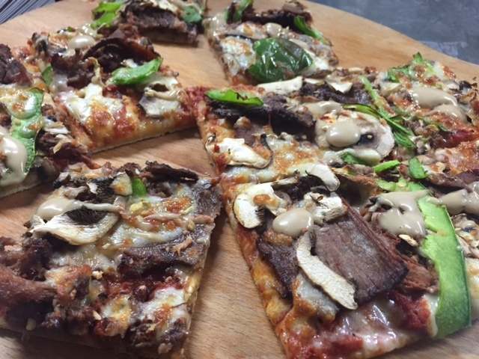

This one felt like the most “gourmet” of the new range utiling 4 star wagyu beef (that's better quality than most restaurants!); the use of Japanese style flavours and ingredients on this pizza made it really unique and thoroughly enjoyable too.

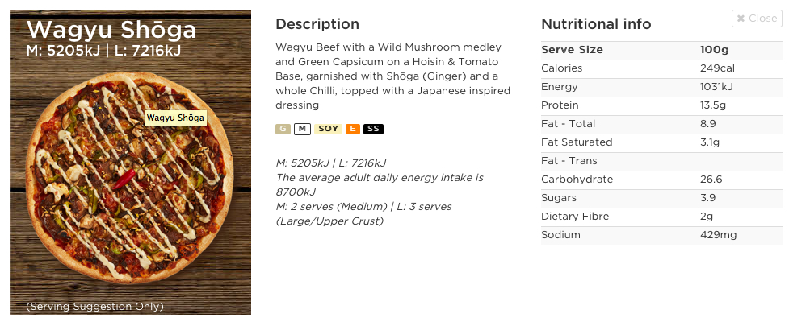

Nutritional thoughts:

For a moment I will put on my dietitian hat for us all;

If we look at the nutritional information per 100g serve, based on common nutritional claims (with associated figures) that can be made, the positives that are standing out to me include:

Low sugar - With less than a teaspoon per 100g serve
High protein – All with more than 10g per 100g serve
Moderate sodium – less than 450mg per 100g serve

My guess is that most people would end up eating closer to 200 or 300g in a sitting, so if we keep that in mind, the protein provided would be closer to 25g per serve, the sugar is still down at less than 4%, and the sodium naturally does begin to creep up in terms of provision from the one meal (but still rates favourably compared to many other pizzas out there).

The pizzas do contain small amounts of dietary fibre compared to pizzas that lack vegetable toppings and are made from refined white bases, however given we all know how much I am a fibre fan, I think serving these pizzas alongside a salad would be ideal! This would also help bulk up the meal so that you don't end up overeating extra pieces and having portion sizes far larger than initially suggested by Crust.
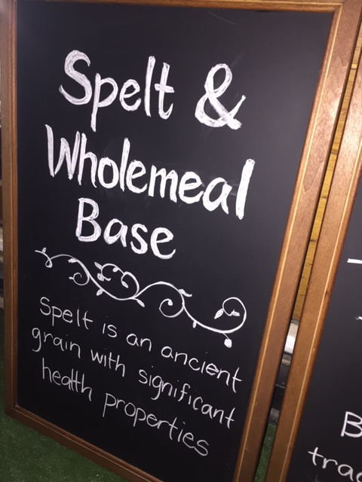

I think compared to many of the other pizza options on the market which are either extremely high in sodium and/ or sugar as a result of the sauces used, or extremely high in sodium and become quite calorie dense from the processed meats that are used, these new options are a great alternative when looking for a take-away pizza option.

I like that they are sourcing local produce and that there is a focus on ingredient quality as opposed to just the final nutrition information panel.
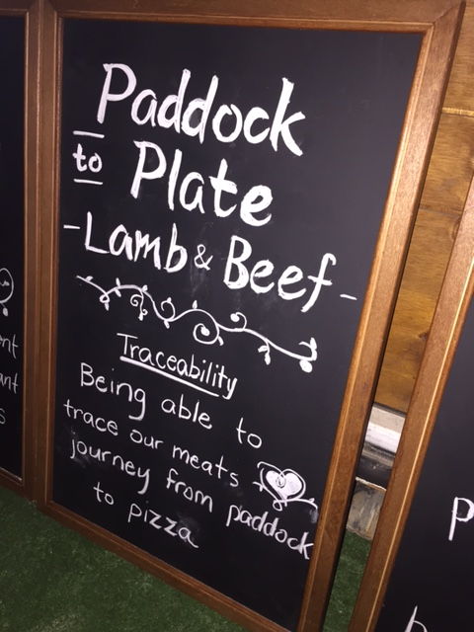

Knowing that care is being taken regarding what is inside our food (and what additives have been left out), as well as the transparency provided by the company are all huge positives in my eyes.

You can find out further information on the new “Simply Better” range by heading over to the Crust website (insert link).

I hope you found this information useful,

Until next time,

TD x

